**IDX G9 MATH S STUDY GUIDE ISSUE 2**

**By Gorden**

- a set is a collection of different items, called elements. we write sets inside { }.

- elements: each item in a set is called an "element". if an element is in a set, we write it as ∈. for example, if A = {1, 2, 3}, then 2 ∈ A.

- types of sets:

- finite set: a set with a limited number of elements, like {1, 2, 3}.

- infinite set: a set with unlimited elements, like {1, 2, 3, ...}.

- empty set: a set with no elements, shown as {} or ∅.

- subset: set a is a subset of set B (written A ⊆ B) if every element in A is also in B.

- universal Set: a set that has all possible elements in a certain situation, usually shown as U.

- operations on sets:

- union (∪): combines all elements from two sets.

- intersection (∩): finds elements both sets have in common.

- complement (A'): elements that are not in the set, but in the universal set U.

- lnductive reasoning: based on the pattern, using inductive reasoning can tell you the next few terms in the sequence.

- counterexample: example that disproves the conjecture.

- conditional: if p then q. p implies q.

- example: if today is raining, I need to bring an umbrella

- converse: if q then p. q implies p. (the opposite of conditional, but it might not be true)

- example: if I brought a umbrella, today is raining.

- biconditional: p if and only if q (both the converse and conditional must be true)

- deductive reasoning: consists of 2 laws: Law of detachment and Law of syllogism.

- law of detachment: If p then q, p is true, then q is true.

- law of syllogism: p=q, q=r, then p=r.

- reasoning in algebra

- addition POE: if a=b, a+c=b+c

- subtraction POE if a=b, a-c=b-c

- multiplication POE if a=b, ac=bc

- division POE if a=b and c≠0, a/c=b/c

- reflexive POE a=a

- transitive PO if a=b, b=a

- substitution POE if a=b, then b can replace a in any expression

- distributive POE a(b+c)=ab+ac

- reflexive POC line ab≅line ab

- symmetric POC if line ab ≅ line cd, then line cd ≅ line ab

- transitive POC if line ab ≅ line cd, line cd ≅ line ef, then line ab ≅ line ef

- supplementary angles: two angles add up to 180

- complementary angles: two angles add up to 90

-theorems

- vertical angles theorem: vertical angle are ≅

- content supplement theorem: If two angles are supplements of the same angle (or of congruent angles), then the two angles are ≅

- congruent complement theorem: If two angles are complements of the same angle (or of congruent angles), then the two angles are ≅

- All right angles are ≅

- If two angles are congruent and supplementary, then each is a right angle

- point lines terms

-Point: a location; no size; represented by a small dot an is named by a single lette

-Line: a series of points that extends in,two opposite directions without end; named as any two points in the line

-Collinear points: points that lie on the same line

-Segment: is the part of a line consisting of 2 endpoints and all points between them.

-Ray: is the part of a line consisting of 1 endpoint and all the points of the line on one side of the endpoint.

-Opposite rays: two collinear rays with the same endpoints.

- parallel lines: two lines not intersecting and not skew

- skew lines: two lines not parallel not intersecting

- parallel planes: planes that never intersect.

- measuring angles

- angle measure larger than 90: obtuse angles

- angle measure smaller than 90: acute angles

- angle measure = 90: right angles

- congrunt angles= angles with same measure

- angle addition postulate: adding the measurement of two angles

- angle bisects: split a angle in half using a line

properties of parallel lines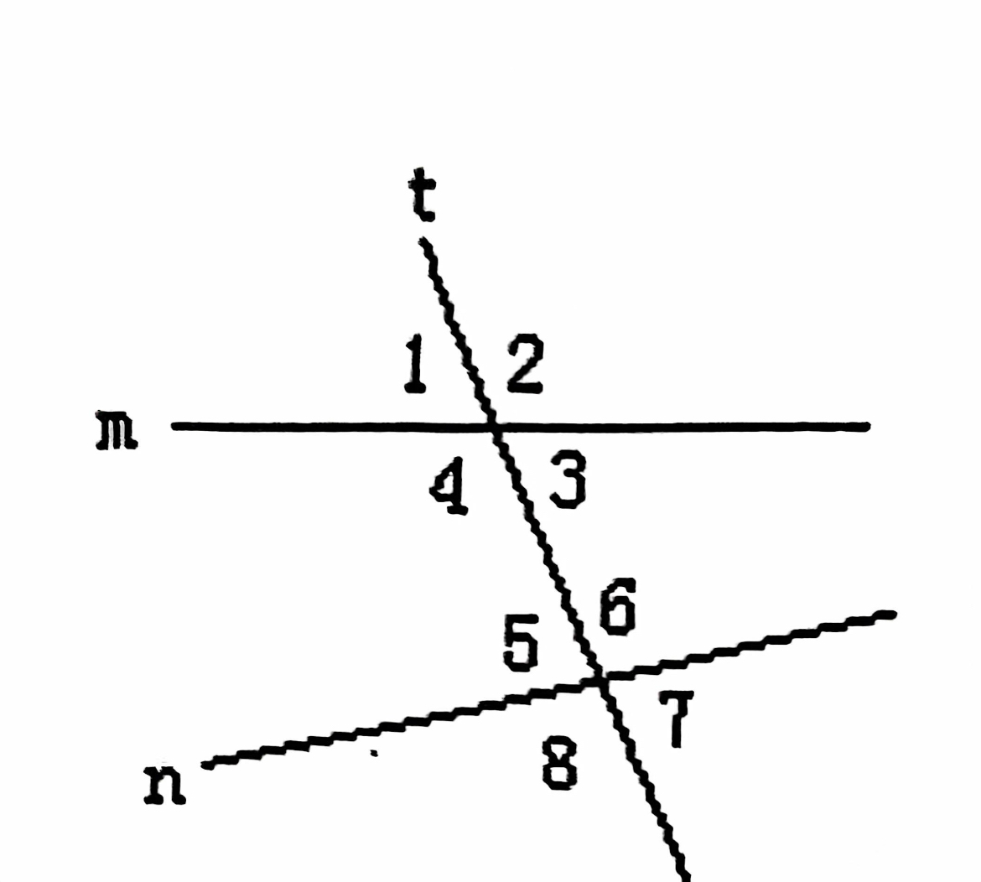

-corresponding angles postulate: if a transversal intersects two parallel lines, then corresponding angles are congruent

-example: angle1 ≅angle5 etc...

-alternate interior angles theorem: if a transversal intersects two parallel lines, then alternate interior angles are congruent

-example: angle4 ≅angle6 etc...

-alternate exterior angles theorem: if a transversal intersects two parallel lines, then alternate exterior angles are congruent

-example: angle1 ≅angle7 etc...

-same side exterior angles theorem: if a transversal intersects two parallel lines, then same side exterior angles are supplementary angles

-example: measure angle1 + measure angle8 =180 etc...

- proving lines parallel: finding the two lines parallel when a transversal and numbers around the transversal are given.

-the opposite of the theorems and postulate in properties of parallel lines

parallel and perpendicular lines

-if two lines are parallel to the same line, then they are // to each other

-in a plane if two lines are perpendicular to the same line, then they are // to each other.

-if a line is perpendicular to one of the parallel lines, then it is also perpendicular to the other.

-triangle angle sum theorem: all angles of the triangle add up to 180

-triangle exterior angle theorem: the measure of one of the exterior angle equals to the sum of two interior angle.

-proving triangles congrunt

- SSS: three sides are congrunt

- SAS: two sides and an included angle is congruent

- ASA: two angles and a included side is congrunt

- AAS: two angles and one side is congruent

- note that the proving way of ASS doesn't exist